***Practical 17☺ :***

**Question:**

Develop a countdown timer, that allows user to set a starting number of seconds and then count down to zero, displaying each second as it decrements. After the countdown completes write ‘Time completed!’.

**Code:**

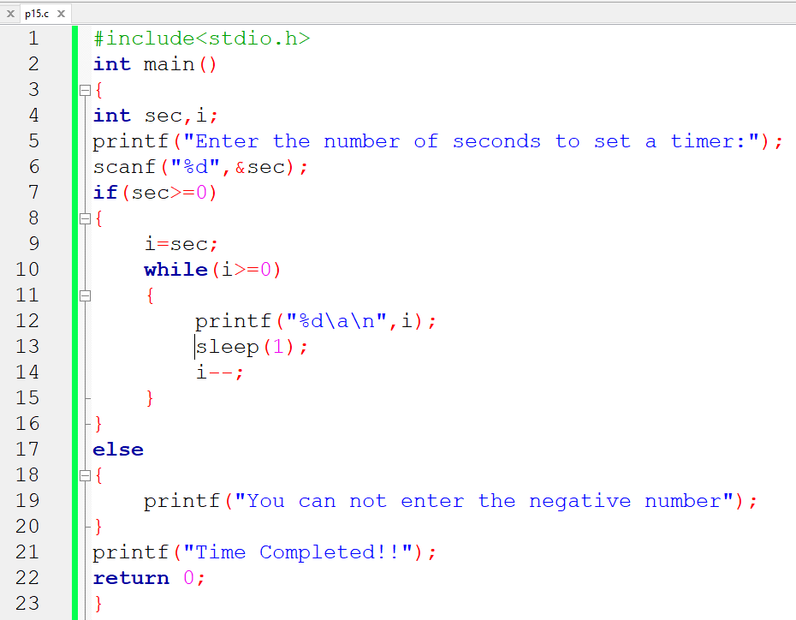

**Output:**

